**Math for Game Designer – Final Class Discussion**

In the final project of Math for Game Designers, I’m going to make a game which implements 3 concepts – Triangle, Vector Math (Dot Product to be specific), and Randomness, that we’ve introduced in the class.

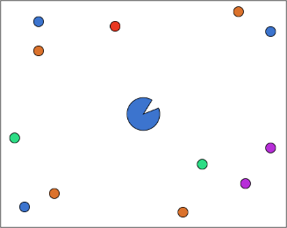

Figure – 1, Game scene preview

**Randomness:**

The game concept is very simple. The player controls a circle with a 15-30 degree gap at the center of the scene. At the border of the scene, there will instantiate balls at random position and in random color (Predesigned colors in an Array. I’m going to use random index instead of the real random color). The ball will move towards to the player. In the meantime, the player’s color will be randomly changed to the same color which some of the balls have. To tell the player, which ball the circle will prefer to catch.

**Vector Math (Dot Product):**

There will be no trigger in the game to detect the ball touched the circle. I’ll use Dot Product to detect the ball is inside the 15-30 degree gap or not when the ball reaches to the player. The ball will be destroyed when it is within a predefined minimum range (this range surrounds the player). If the same color ball is captured by the player, player will win a score. If the player captured the ball with a different color or missed the ball with the same color, the player will lose a life. The player has 3 lives. When life is 0, the game is over.

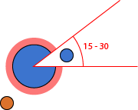

Figure – 2

Vector Math (Dot Product) to detect the ball is within the acceptable area or not

**Triangle:**

The player controls the circle rotation by mouse movement or the left stick on game controller to face the gap to the ball. Mouse or the left stick on game controller movement will return a vector2 value contains X (range is -1 to 1) and Y (range is -1 to 1). By using this vector2 value in Matfh.Atan2() method, the program will return an angle in Radians. So the circle will face to the direction the player inputs.

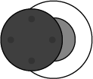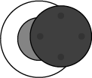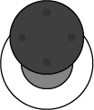 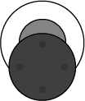

Figure – 3

Game Controller stick value: x = -1, x = 1, y = 1, y = -1

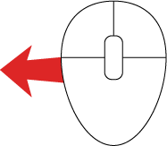 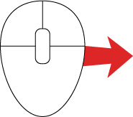 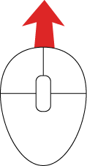 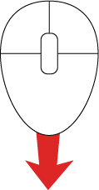

Figure – 4

Mouse Movement returns value in x = -1, x = 1, y = 1, y = -1

This is the basic concept of the final project which will implement 3 math theories covered in the class­.